

Ohio Farm to ECE Racial Equity Roadmap

Prepared by

Vedette R. Gavin MPA, MPH

PRINCIPAL

Verge Impact Partners

Prepared for

The Ohio Farm to ECE Coalition

August 2022

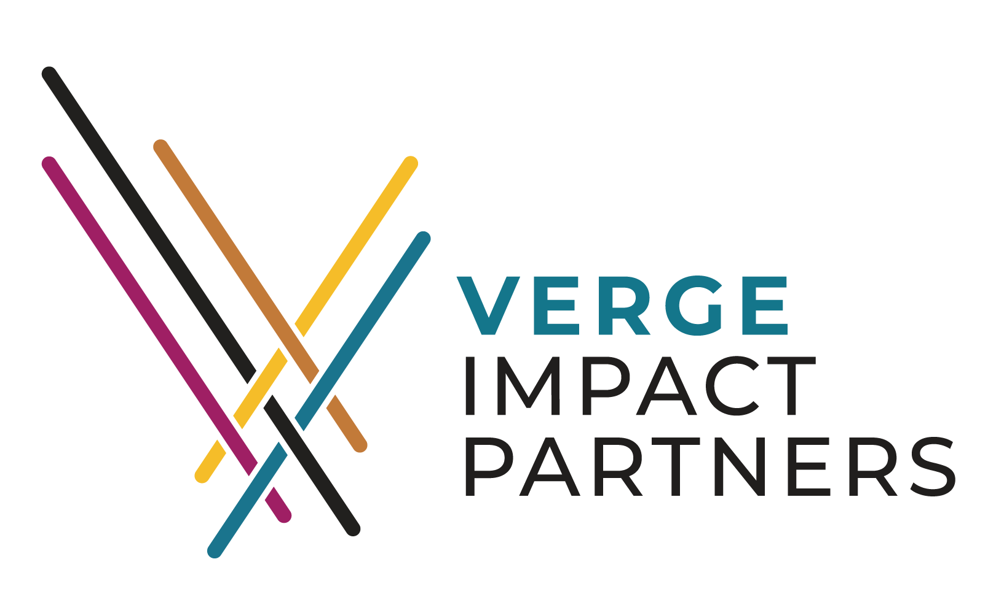

**Section 1: Background**

The Ohio Farm to Early Care and Education (ECE) Racial Equity Roadmap (the Roadmap) outlines a two year capacity building, learning, and high impact planning and action work that the Farm to ECE coalition undertook to integrate an intentional focus on advancing racial equity in food access into their work.

## 

Farm to early care and education (Farm to ECE) efforts bring local foods into ECE settings, including preschools, child care centers, family child care homes, Head Start/Early Head Start, programs in K-12 school districts, to assure access to health and fresh food while enhancing the educational and learning environment.

### **Who we are**

The Ohio Farm to ECE Coalition uses a quality improvement approach to improve the way that policies and systems in Ohio enhance or limit the supply and access to healthy food. Together, partners from various nodes of the food system design, test, and scale high strategies to improve overall performance and outcomes of ECE systems. Our work for 2020 through 2022 is focused on:

* Increasing the quality of ECE settings and access to healthy environments
* Providing technical guidance and funding to strengthen and build diverse, multi-organizational, state farm to ECE coalitions
* Networking with other states and experts working on farm to ECE
* Sustaining local food systems in the state
* Helping farm to ECE stakeholders sustainably respond to COVID-19 challenges and
* Implementing practices and PSE changes to support state-level farm to ECE

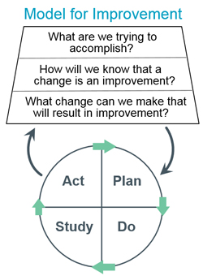

**How we work**

Systems improvement requires change, but not all changes are improvements. The Ohio Farm to ECE coalition uses the PDSA approach to understand what types of changes are needed in local food systems to improve capacity and outcomes. PDSA cycles are rapid ways to develop strategies to test potential changes (Plan), carry out the test (Do), observe and learn from the consequences (Study), and determine what modifications should be made to the test to achieve the desired outcome (Act).[1]

Each year, we repeat PDSA cycles around three “drivers”, or high impact levers, of quality improvement in the Ohio Farm to ECE ecosystem to ensure we strategically plan and learn as we work to improve access to fresh and healthy food for all of Ohio’s young children.

**Our 3 driver areas of work are:**

➤ **Driver 1:** State Level Coalition Development

➤ **Driver 2:** Policy Education and Guidance

➤ **Driver 3:** Procurement Innovation

**Section 2: Why Racial Equity?**

In 2019, the Farm to ECE Coalition recognized that they could not reach their universal goal of ensuring all children in the state of Ohio have access to local foods without understanding and addressing the reasons and ways that Ohio’s food and early care systems are currently failing to meet those needs for some children while successfully providing them for others.

Observing decades of racial disparities in food access and outcomes data, the coalition engaged Verge Impact Partners to guide them in integrating an intentional and integrated focus on advancing racial equity in their work together as a coalition and through their statewide Farm to ECE quality improvement work. This work included 3 phases:

**Phase 1: Capacity Building (2019)**

Developing a shared understanding of language, historical context, and skills to engage in racial equity conversations and work as a coalition

**Phase 2: Planning (2020)**

1. Incorporating a commitment to racial equity into the coalition's mission, vision, governance and working norms
2. Identifying the root causes of racial inequities in the food system to be addressed through their quality improvement work

**Phase 3: Application**

1. Expanding and diversifying the membership of the coalition to include representatives with power to influence the systems they are working to improve AND members of the communities and populations they intend to impact.
2. Integrating a racial equity approach into their ongoing work

### **VIP’s Framework for Racial Equity**

VIP’s framework for racial equity utilizes a core set of key definitions and three core equity practices - methods for both understanding and achieving racial equity that are to be applied rather than just theorized about.

|  |  |  |
| --- | --- | --- |
| **Racial Equity Practice** **#1** | **Racial Equity Practice #2** | **Racial Equity Practice #3** |
| ➤ Identify and address root causes | ➤ Understand and shift power imbalances, identify and check privilege | ➤ Include and directly benefit those who have been excluded and/or harmed |

**Why these practices?**

These practices are rooted in a framework of targeted universalism: where ‘universalism’ is a principle that treats all people the same, independent of culture, race, ethnicity, and other forms of identity. Within a “targeted universalism” framework, universal goals are also established for everyone, but the strategies developed to achieve those goals are targeted, based upon how different groups are situated within structures, culture, and across geographies to ensure that they can successfully achieve the universal goal.

**Universalism is akin to equality, whereas targeted universalism is more directly related to equity.**

The latter responds to differing baselines, which result from layered historic and institutional actions. “Targeted universalism” is goal-oriented, with the intention of bringing everyone to the same baseline, and to a point where universal goals and processes truly work for all. Key to this approach is setting goals that can have the greatest impact to change rather than what is easiest or most comfortable. 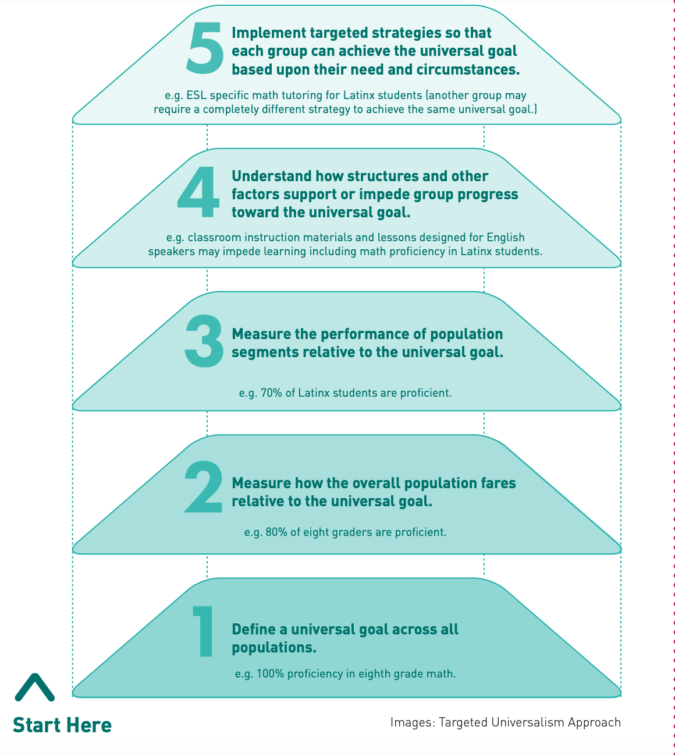

This framework also affirms the voices and choices of racially minoritized communities in framing the problem (and the narrative) as well as developing targeted strategies, even when existing data may not always seem to substantiate it. The implementation of “targeted universalism” involves five layers and can be applied to address a wide range of racial equity priorities.

**Section 3: Outcomes and Resources from our Work Thus Far**

### **Phase 1 Results - Capacity building**

In this phase we learned and applied new terms, language, and perspectives that enabled us to identify, closely examine, and name the implications of the dominance of whiteness and structural reinforcement of anti-Blackness in our communities, policies, societal norms, and our work as a coalition.

➤ Resource - VIP Primer on Racial Equity Key Terms ([linked here](https://docs.google.com/presentation/d/1zCqCp2d7l7FJNp7-KB43KrUOkdSIPo0E/edit#slide=id.p1)) followed by Structuring for Equity ([linked here](https://docs.google.com/presentation/d/1bz7ycnZkyYH0TXqunrWg4kgVMxZwMHvN/edit#slide=id.p1)).

### 

### **Phase 2 Results - Planning**

In this phase we utilized our understanding of those key racial equity terms and concepts to incorporate an intentional and clear commitment to racial equity into our vision, populations of focus, values, coalition membership, and working norms.

➤ **vision:** Equity will be achieved when all children 0-5 have access to healthy and nutritious

food in their childcare settings and at home and this is not disproportionately determined by race, income level, education level and knowledge about nutritious food and how to prepare food, childcare type, or home address in the state of Ohio.

➤ **who we serve:** To focus our work on advancing racial equity, we will focus our strategy and impact on ways and setting to impact children of color in urban and rural communities across that state of Ohio, including:

* Childcare centers and educators who lack access to fresh and health food
* Children who lack access to healthy food in their childcare setting or at home
* Families and caregivers of children of color who lack access to healthy food in their home settings (there are many factors at play that contribute to this lack of access. This group is not a monolith)

➤ **values and working norms**: to advance our work with an equity lens, we must be able to: connect with, listen to, and hear one another, understand where we agree and disagree, and decide how to move forward together. To do these things, we commit to the following values:

|  |  |
| --- | --- |
| Communication  Listening  The ability for everyone to speak and express themselves  Respect where others are coming from  Intentionally multicultural | Partnerships  Trust Collaboration  Teamwork Mutuality  Sharing resources Self-determination  Authentic relationships Sponsorship |
| Decision-making  Open to all ideas Representation  Commitment Dependability  Mutual respect Collaboration  Accountability  Safe space to disagree/share ideas  Decision-makers at the table | Conduct  Safe space Inclusivity  Dependability  Purposeful interactions that include everyone  Reject hatred, racism, and bigotry |

➤ **coalition membership**: to ensure that we both addressed root causes and directly included and benefited the people and communities we serve we reset our coalition table. When we began our journey, our membership was 100% white and 100% from the professional vs community settings we serve. To shift this, we identified key root causes of racial inequities of access to fresh, healthy food in ECE settings across Ohio and invited community members impacted by or working to change those systems, and practitioners working in the systems we aim to improve.

Key root causes include:

* Access to capital for ECE providers of color or provider serving lower income communities due to perceived risk
* Societal undervaluing of care work and daycare rooted in under-compensation of the labor of women of color.
* Inconsistencies in regulations, requirements, and resources across local health departments
* Cost burden to providers that make healthy and fresh options unaffordable
* Societal and family values and perceptions of healthy and fresh food
* Parental access to healthy food rooted in wage inequality and local access to healthy food options

**Section 4: 2022 Ohio ECE Racial Equity Roadmap**

This year, with new members at the table, we utilized the racial equity practices set and advanced a “racial equity aim” into our ongoing work in the 3 driver areas.

*A “racial equity aim” is a measurable, time sensitive, achievable, realistic goal that is focused on advancing racial equity through our work in each driver area.*

The roadmap below documents the collaborative thinking and plans of the Ohio Farm to ECE Coalition on how to improve Farm to ECE capacity, connections, and impact through their work in each driver area in 2022. This roadmap is both a guide, outlining the strategies and specific action steps to be taken, and charge to seek out and optimize opportunities to learn what it takes to improve access through an intentional focus on racial equity. It acknowledges that this is work that The Coalition has not done before, and that doing it well will require new knowledge, new partners, and working in new ways.

Roadmap Components:

* Driver area
* Strategies - *broad approach we will take to accomplish to improve this driver*
* Racial Equity Aim and key levers - *what we want to achieve and critical actions and/or learning we must achieve to get there*
* Actions - *specific activities we will complete to accomplish our*
* Actors - *who will lead the actions*
* Milestones - *how we will know we’re headed in the right direction*

### **Diver area 1: State Level Coalition Development**

The people invited to the table determine what’s on the table, and what actually gets accomplished. To deepen our capacity to design and advance systems change work to achieve more racially just outcomes, we will 1. Expand and diversify our state-level coalition to include representation from the communities more adversely impacted, and 2. Establish sustainable and equitable coalition recruitment, onboarding, shared governance, participation, decision-making, compensation, and evaluation guidelines and working norms.

|  |  |  |
| --- | --- | --- |
| Driver area 1: State level coalition development | | |
| **Racial Equity Aim and Key Levers**  Expand and diversify our state-level coalition to include representation from adversely impacted communities | | |
| **Strategies** | **Actions** (critical racial equity practice) | **Actors** |
| **1.1** Expand and diversify our state-level coalition to include representation from the communities more adversely impacted | Review application process | Coalition development working group |
| Identify demographics and experiences needed at the table | Full coalition membership |
| Identify [specific organizations or people](https://docs.google.com/presentation/d/1U6wGUn9vyf1GnsAyznZNUqLEKY1hk0KF4q6xm5L7kTQ/edit?usp=sharing) *(slide 12)* with those demographics and experiences to invite. | Full coalition membership |
| Review applicants from previous years   * Determine the number of people to accept this round. * Ask coalition members to reach out to more People of Color with lived experience. * Call organizations/people back. If they’re not interested, ask if they can recommend someone else. * Have potential members fill out an interest form and submit to the coalition development group lead. | Coalition development working group |
| Develop application review criteria   * Review and update existing criteria as needed, with Racial Equity Aims, mission, vision, and values in mind. * Make recommendations back to the full coalition for input/feedback. | Coalition development working group |
| Review applications   * Make recommendations back to the full coalition for input/feedback | Coalition development working group |
| Accept new members:   * make decision to accept or reject applicants, based on recommendation of coalition working group *(determine how you will decide, eg. consensus, majority, scoring)* * Email acceptance letter to new members | Full coalition membership  Coalition development working group |
| Onboard new members:   * Email critical onboard documents * Call them via phone to welcome them and see what Driver areas they are more interested in supporting * Honorarium logistics/instructions * Add new member bios to the roster and share with the full membership of the coalition to ensure everyone knows who is at the table * Update members on progress to date and work ahead so that they come into the work informed | Coalition development working group |
| **Milestones**  Short term: Identified and built relationships with contacts from community organizations, growers, and child care sites led by or serving communities and families of color (see “who we serve” p.5) and invited them to join the coalition.  Mid-term: You review and revise your invitation/application and acceptance process and criteria to support the inclusion of people with lived experience from impacted communities of color.  Ultimate: At least half of total coalition members are people with lived experience from impacted communities or care settings AND at least half members are people of color representing impacted communities. | | |

### 

### 

### **Driver area 2: Policy and Education Guidance**

In talking with early care providers and agency staff, it became apparent that an immediate barrier to using and serving local and garden-grown produce in our state is a lack of understanding of how to comply with existing food safety regulations, particularly in centers servicing lower income communities of color in both urban and rural settings. While these policies, and the processes that reinforce them in limiting ways, are the ultimate structural factors we want to change, we need to learn more about what works for those providers in particular.

As a first step to learn what works, we are developing information sheets and videos to demonstrate how foods grown in school gardens or purchased from local farmers or markets can indeed be used for educational activities and served to children in meals and snacks within the required guidelines and policies, and learning how this guidance works for sites servicing lower income communities of color in both urban and rural settings. We will incorporate these resources into professional development and websites, we will explore and identify potential licensing rules to recommend for adoption in Ohio.

|  |  |  |
| --- | --- | --- |
| Driver area 2: Policy education and guidance | | |
| **Racial Equity Aim and Key Levers**  Increase the amount of local healthy foods being used in ECE classrooms serving families and communities of color and low-income, urban and rural, communities by: 1) improving the capability (knowledge + skill) of ECE providers to comply with state regulations to properly access, prepare, and utilize local food in ECE classrooms, and 2) ensure educational materials on how to do this reach providers of color and providers servicing communities of color. | | |
| **Strategies**  **2.1** Create information sheets and videos to demonstrate how foods grown in school gardens or purchased from local farmers can be used for educational activities and served to children in meals and snacks. | **Actions** (critical racial equity practice) | **Actors** |
| Hold listening sessions to find out what barriers providers are experiencing in growing and using local foods, particularly providers serving children of racial minority groups, located in minority communities who lack access to fresh food in ECE settings | Policy working group |
| Determine who has or doesn’t have access to training platforms (by race and income) and why they don’t have access.   * Contact ODE to figure out what data/information is available to you, by race (of provider or population served, if available) and geography. * Determine what format you need the data and how you will access it, analyze it, or partner with someone who can do that for you. * Use the data to determine where there are gaps in provider use of the portal by race and geography. | Policy working group |
| Finalize materials for providers   * Determine the specific racial, cultural graphic groups do you need to share materials with * Determine how to culturally and linguistically tailor the materials for these groups. * Identify representatives from these groups to review and provide feedback on the materials. | Policy working group |
| Make translated materials available to all providers through portals (eg. state training portal) AND local partners.   * Determine what portals are available to you to host materials for providers, and get permission to share the materials (ODE, ODJFS, referral agencies, licensing agencies, school systems etc.) * Identify other ways to reach providers who lack access, including provider training networks, conferences, and programs that can share materials with providers they engage. * Determine how you will track your progress reaching providers of focus. | Policy working group |
| Educate parents so that they are informed consumers   * Identify resources that providers can use to share information with parents of children in your populations of focus, eg. content to include in newsletters or emails that providers send to parents, materials to send home with children * Determine short- and long-term ways to get materials to providers. * Determine how you will track your progress reaching parents of children in your population of focus. | Full coalition  Policy working group |
| **2.2** Revisit original concern about licensing rules and identify potential policy changes to recommend for adoption in Ohio. | Use what you learn in aim 2.1 to identify the level and types of policies that are barriers or helps to providers. These can be “P” policies created by elected officials and institutions, or “p” policies that guide processes, program budgets and guideline, and decision-making criteria within organizations, programs, fields of practice, or programs | Full Coalition |
| Complete a factor map to analyze policy and systems change options, and their potential helps or harms for your populations of focus and identify those that are most feasible for your coalition to advocate for.  Identify the unique barriers and supports for minority providers/providers serving your population of focus, and the barriers and supports that are common for providers in all settings serving all populations (integrate learning from the procurement group) | Policy working group  Policy and procurement working groups |
| Complete a power mapping exercise to identify current and potential partners you need to engage that have “power over” or who you can build “power with” to help change selected policies | Full coalition |
| Develop a working plan to engage those partners in advocating for policy change | Policy working group |
| **Milestones** *(in the milestones below, population(s) of focus = children in racial minority groups or communities that lack access to fresh and healthy food in ECE settings)*  Short term   * You determined how many providers are accessing or using the training portal materials by geography and race (provider and population they serve, where possible) * You determined how many providers are participating in ECE activities by geography and race (provider and population they serve, where possible) * You identified the motivators and barriers specific to providers serving children in your populations of focus * Videos and information sheets are culturally tailored and completed.   Mid term   * Providers of color, providers serving communities of color, and providers serving low-income communities utilize the state training portal. * You are able to track providers accessing materials and/or completing by geography and race (provider and population they serve, where possible)   Long term  - More providers across the state participate in ECE activities  - More providers serving you populations of focus participate in ECE activities | | |

**Driver 3: Procurement Innovation**

Based on the needs assessments we conducted in 2019, we gathered feedback and data to help us develop tools to provide more technical assistance on local procurement and garden education. We recognized that to reach children across the state, to scale, we need to build an ECE infrastructure that makes it possible for farmers, producers, and ECE providers to access what they need. We also recognized that communities of color and lower income rural areas are far less likely to have organizations or coalitions coordinating action in these areas. To help develop the Farm to ECE infrastructure we need across the state of Ohio, starting with the communities most disproportionately and adversely impact, we will

* Provide local procurement and garden education TA for ECE sites in Ohio through regional ECE networks between farmers and early care providers
* Engaging Head Start and non-Head Start sites by connecting them with regional Farm to ECE hubs.

|  |  |  |
| --- | --- | --- |
| Driver area 3: Procurement Innovation | | |
| **Racial Equity Aim and Key Levers**  Focus both strategies on Black farmers, economically disadvantaged farmers, ECE staff and children (specifically racial minorities and rural communities lacking access to fresh food in ECE settings) | | |
| **Strategies**  **3.1** Provide local procurement and garden education TA for ECE sites in Ohio —> regional ECE networks between farmers and early care providers | **Actions** (critical racial equity practice) | **Actors** |
| Identify existing technical assistance guides, resources, and programs from Ohio communities and other states to serve as a guide for Ohio.  Identify high impact technical assistance needs and opportunities and include best practices and resources on these in the technical assistance guide.   * Review learning from 2019, the policy innovation group, and seek feedback from members of the coalition that are black, economically disadvantaged farmers, or ECE staff serving children lacking access to fresh food in their care and/or home settings * Complete a factor map to identify high impact, transformational factors that can drastically strengthen connections to and participation in ECE hubs across the state, including:   + Maximizing CACFP dollars and other reimbursement funds to purchase fresh healthy food   + Maximizing Child Adult Care Food programs | Procurement working group |
| Increase visibility, relationships, and communication between ECE providers and local growers.   * Identity farmers, (particularly Black framers) and ECE providers in each region of the state who are currently involved in ECE activities (by geography and race and income of population served, where possible) * Develop the platform and capacity for ECE partners to connect with other partners, information, and resources in their regional hubs or in hubs across the state | Procurement working group |
| **3.2**  Engage Head Start and non Head Start sites —> connect regional farm to school with farm ECE | Identify Head Start and non-Head Start providers to invite to participate in the pilot   * Ensure that providers from both groups serve your populations of focus (providers serving children from racial minority groups, or who live in low-income minority communities (urban or rural) who lack access to fresh food in ECE settings) | Procurement working group |
| Provide ongoing technical assistance to build knowledge, capacity, and action to increase Farm to ECE activities at sites   * Share the resource guide with pilot sites * Conduct monthly check-ins through surveys, email, or phone calls to identify needs and capacity gaps, and what’s going well for head-start and non-head start pilot sites. * Identify the unique barriers and supports for pilot sites, and the barriers and supports that are common for providers in all settings serving all populations (integrate learning from policy group work to identify barriers) * Update the resource guide based on what you learn. | OSU staff  Policy and Procurement working groups |
| Build regional connections, capacity, and participation in ECE networks   * Connect pilot sites to more experienced sites in their regional network for peer learning * Amplify success of ECE providers across the state you have worked with or helped through your policy or program work, particularly providers in lower income minority or rural communities or serving lower income minority/rural children who lack access to fresh, health food in ECE settings * Fund or build partnerships with programs like AmeriCorp to engage young adults with lived experience of growing food or lacking access to food in service opportunities that provide ECE providers, growers, and network/hub coordinators with additional capacity as needed. | Procurement working group |
| **Milestones**  Short term   * You select pilot sites that serve your population of focus * You formalize and share an initial version of a resource guide with Pilot Sites   Med term   * You learn what works, doesn’t work, and what else is needed in the grocery guide based on the perspective of pilot sites and others with lived experience.   Long term   * You create formal regional networks of ECE providers and farmers, particularly Black farmers | | |

1. Institute for Healthcare Improvement, Quality Improvement Essentials Toolkit. Boston, MA